🏦 Smart Bank Flow

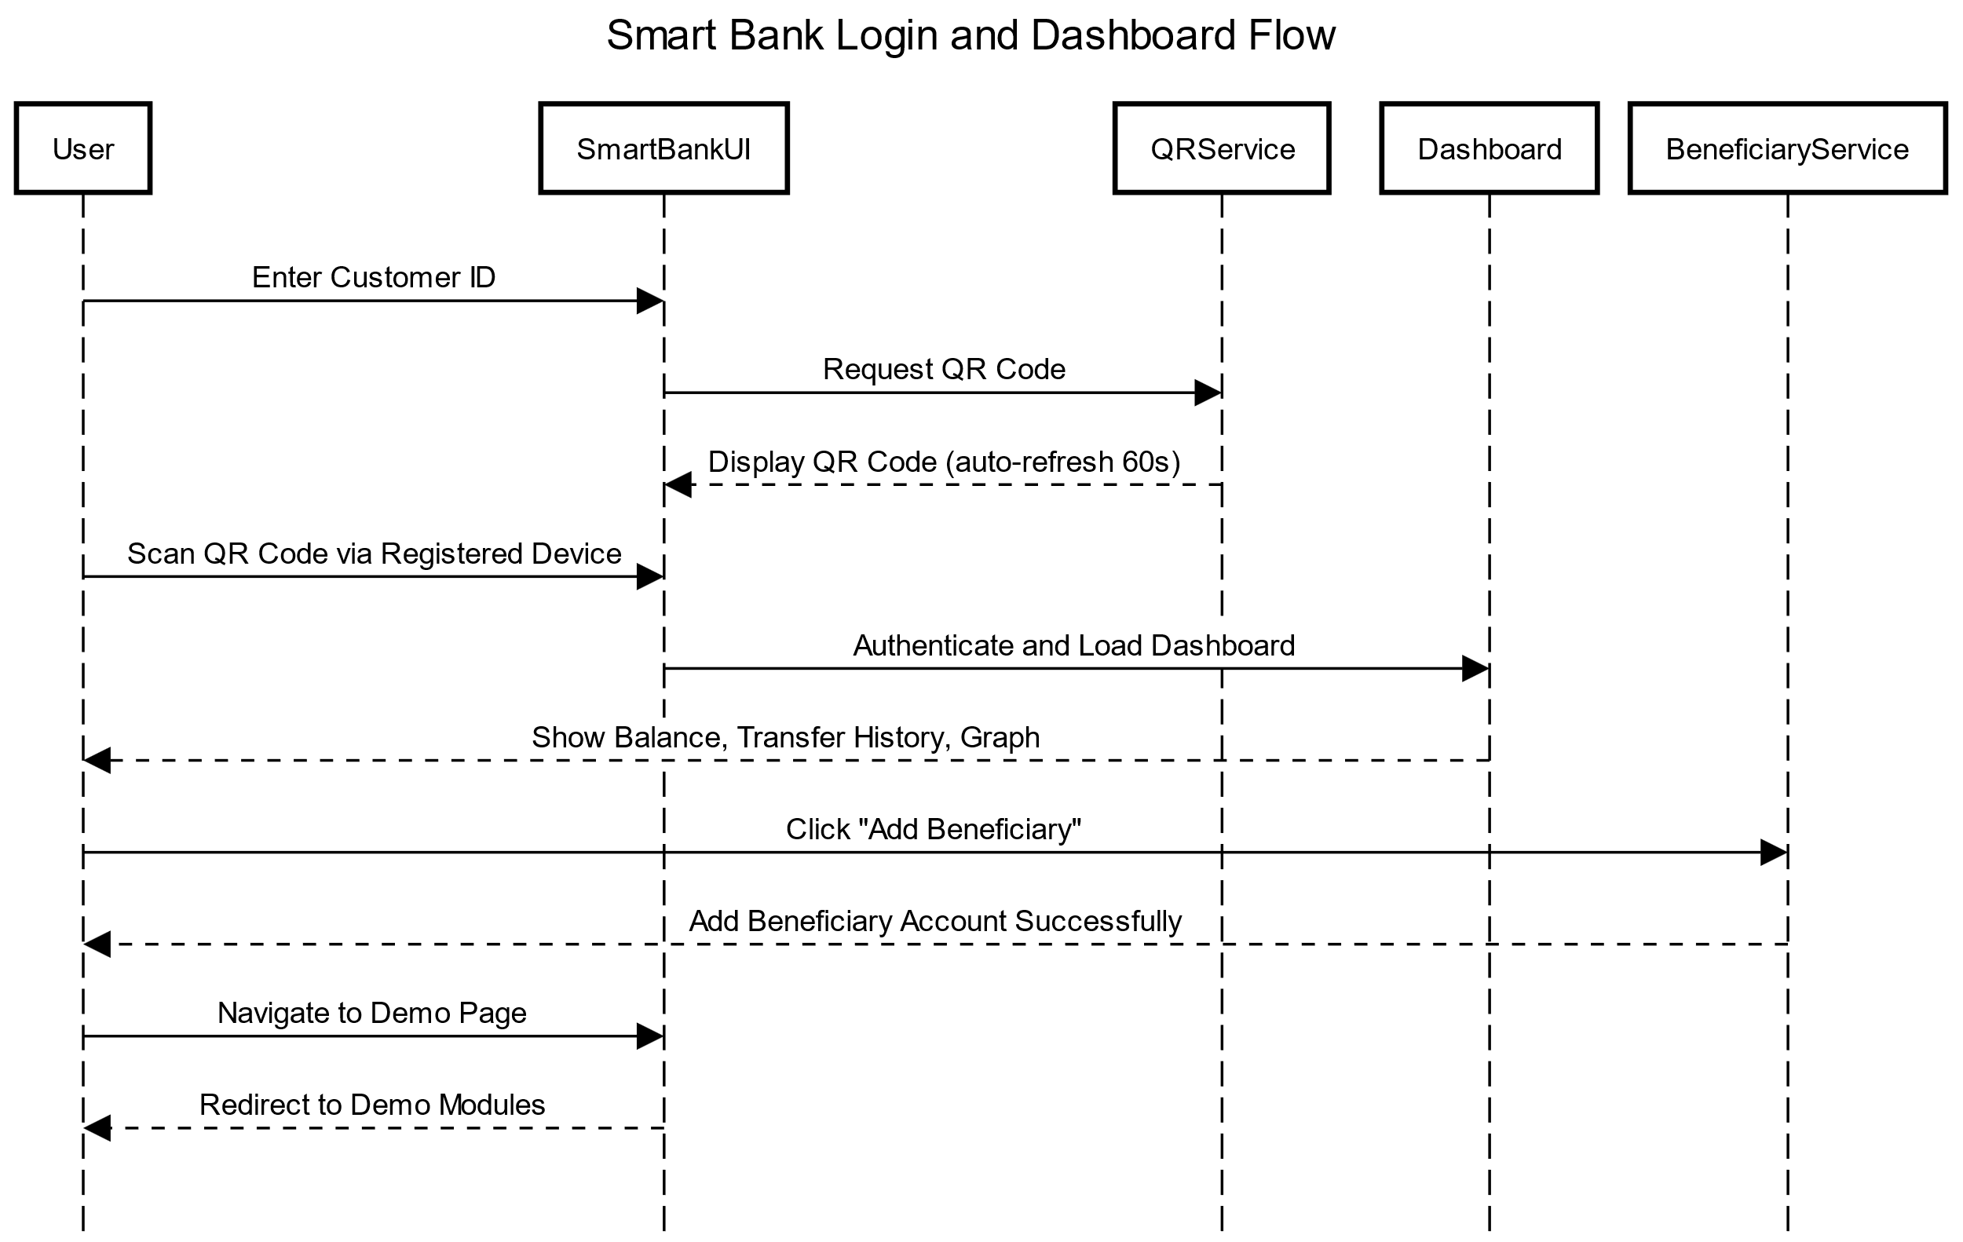

- Login Page: Enter your Customer ID.
- Scan QR Code from your registered device (auto-refreshes every 60 seconds).
- Dashboard shows balance, transfer history, and transaction graph.
- Option to Add Beneficiary for new accounts.
- Navigate to the Demo Page for extra modules.

🏧 ATM Flow

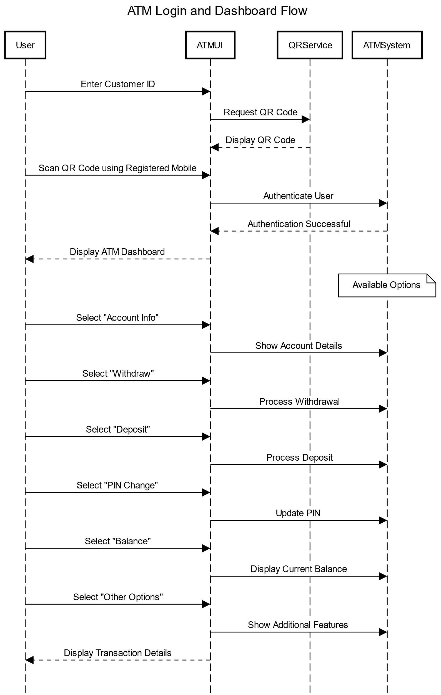

- Enter your Customer ID at ATM login.
- Scan QR Code using your registered phone.
- System authenticates your identity.
- ATM Dashboard displays options:
  - Account Info
  - Withdraw
  - Deposit
  - PIN Change
  - Balance
  - Other Options
- Center screen shows transaction details.

⚙️ Demo Page Flow

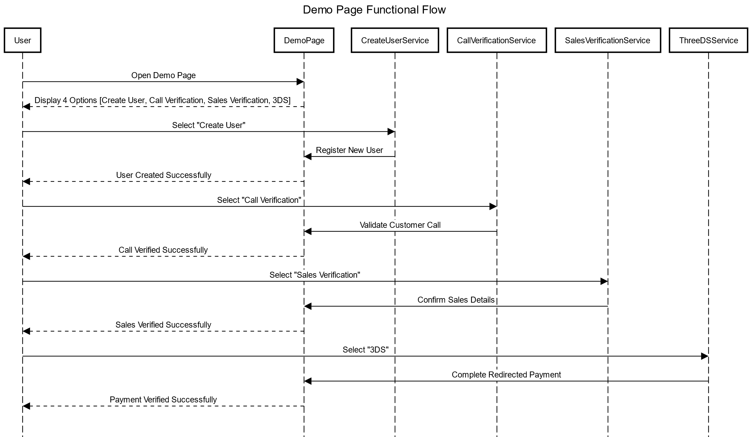

- Access the Demo Page from Smart Bank Dashboard.
- Contains 4 modules:
  - Create User
  - Call Verification
  - Sales Verification
  - 3DS
- Each module performs a different task:
  - Create User: Registers a new user.
  - Call Verification: Validates customer calls.
  - Sales Verification: Confirms sales details.
  - 3DS: Handles online payment authentication.
- Ends by displaying a success message.

